Task 1

NOT Gate

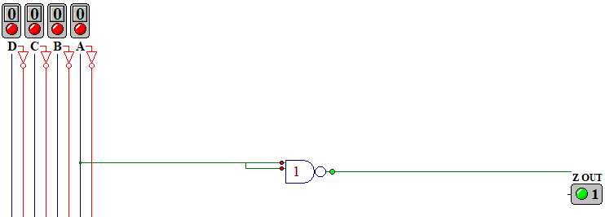

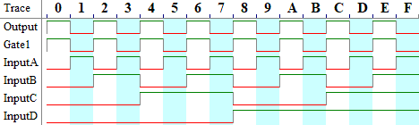

XOR Realization

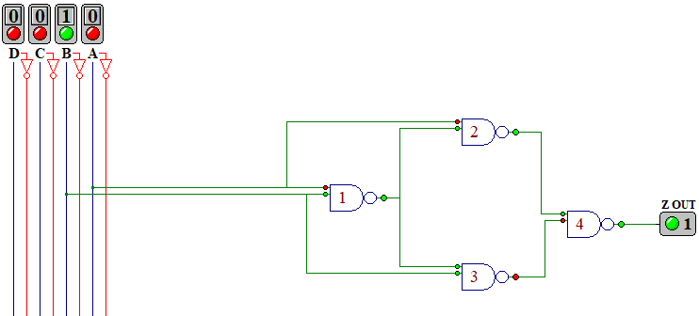

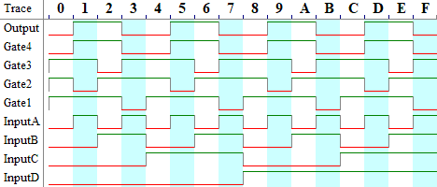

Task 2

2-Input AND gate

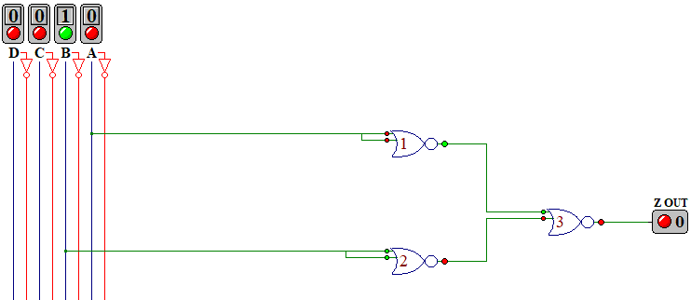

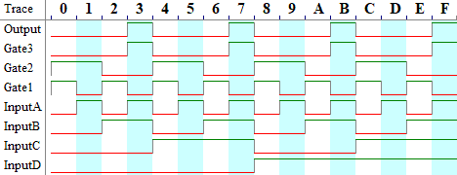

2-Input OR Gate

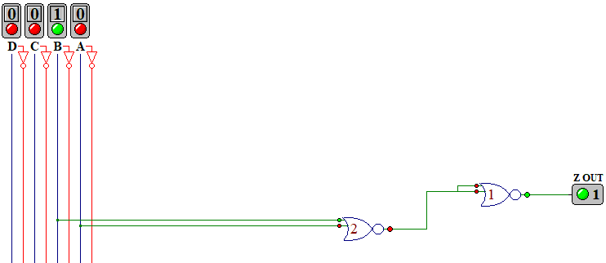

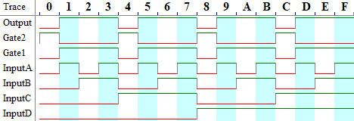

Task 3

|  |  |  |  |  |  |  |  |  |  |  |  |
| --- | --- | --- | --- | --- | --- | --- | --- | --- | --- | --- | --- |
| A | B | C | D | F1 | F2 | F3 | F4 | F5 | F6 | F7 | Dis |
| 0 | 0 | 0 | 0 | 1 | 1 | 1 | 1 | 1 | 1 | 0 | 0 |
| 0 | 0 | 0 | 1 | 0 | 1 | 1 | 0 | 0 | 0 | 0 | 1 |
| 0 | 0 | 1 | 0 | 1 | 1 | 0 | 1 | 1 | 0 | 1 | 2 |
| 0 | 0 | 1 | 1 | 1 | 1 | 1 | 1 | 0 | 0 | 1 | 3 |
| 0 | 1 | 0 | 0 | 0 | 1 | 1 | 0 | 0 | 1 | 1 | 4 |
| 0 | 1 | 0 | 1 | 1 | 0 | 1 | 1 | 0 | 1 | 1 | 5 |
| 0 | 1 | 1 | 0 | 1 | 0 | 1 | 1 | 1 | 1 | 1 | 6 |
| 0 | 1 | 1 | 1 | 1 | 1 | 1 | 0 | 0 | 0 | 0 | 7 |
| 1 | 0 | 0 | 0 | 1 | 1 | 1 | 1 | 1 | 1 | 1 | 8 |
| 1 | 0 | 0 | 1 | 1 | 1 | 1 | 0 | 0 | 1 | 1 | 9 |

For illegal inputs (any number larger than nine) the output is represented by X.

Task4

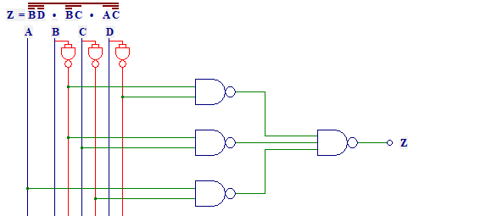

Task 5



